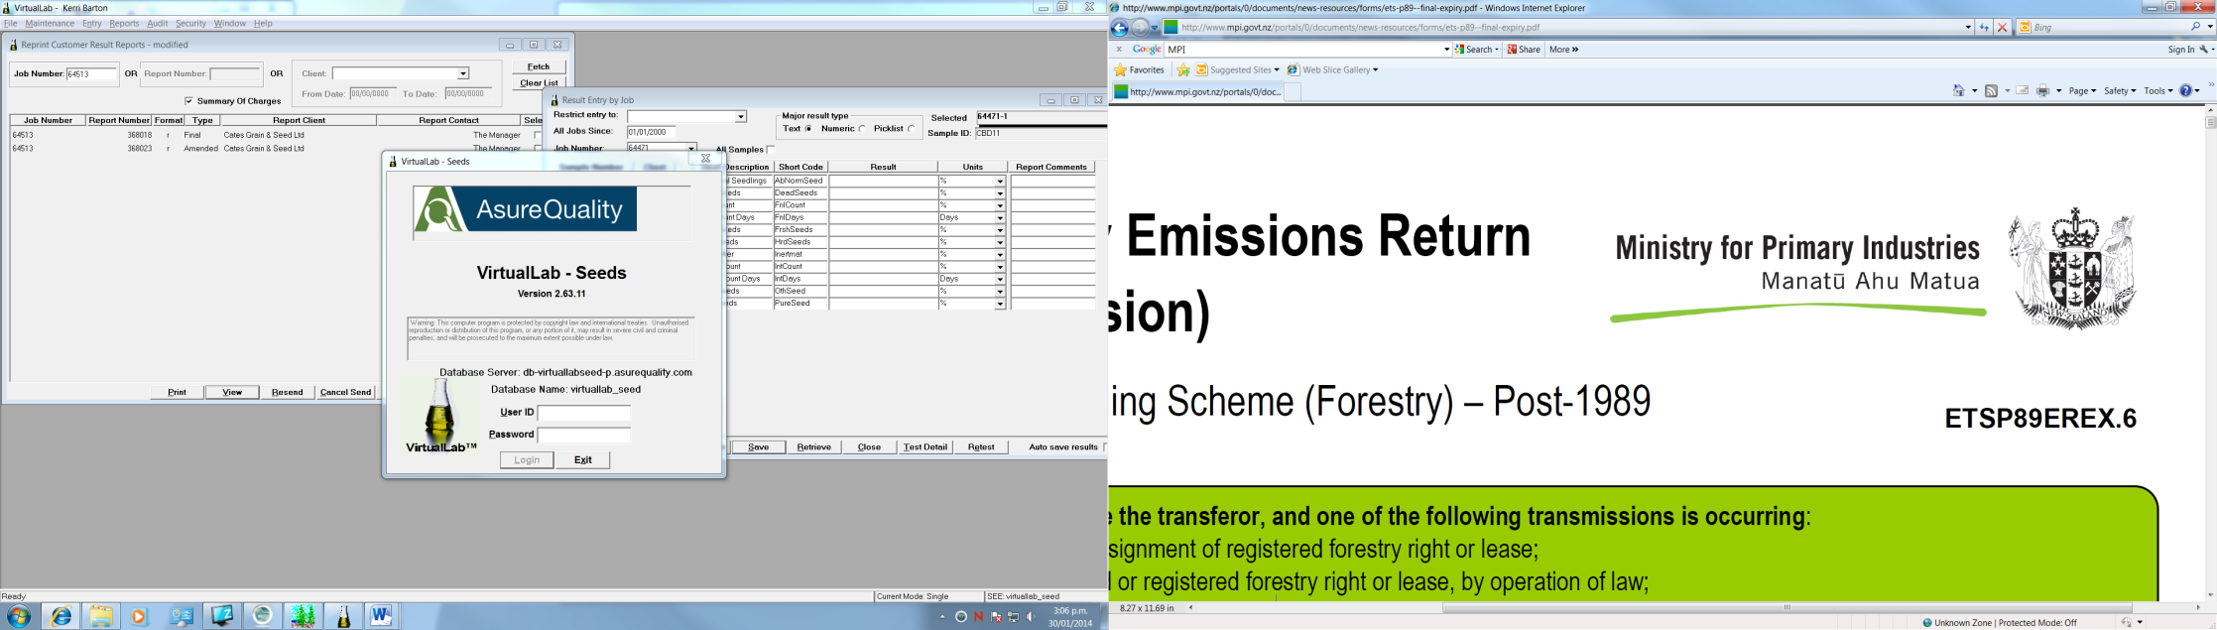 

**New Zealand MPI Seed Varietal Certification Scheme**

**Closing Dates**

**March**  First Monday Beet (spring sown crops)

Kale

**June**  First Monday Beet (autumn sown crops)

Fodder Radish (autumn sown crops)

Rape

Strawberry clover (change of variety)

Swede

Turnip

White Clover (change of variety see below)

**July**  First Monday Cocksfoot

Pea (sown prior to 1 July)

Red Clover (Autumn sown)

Serradella

**September** First Monday Bromes

Browntop

Caucasian Clover

Chicory

Dogstail

Fescue

Festulolium

Lentil

Lotus

Lupins

Phalaris

Plantain

Ryegrass

Strawberry Clover

Timothy

White Clover (see below)

Yorkshire Fog

N**ovember** First Monday Barley

Bean

Fodder Radish (spring sown crops)

Linseed

Lucerne

Oat

Pea (if sown after 1 July)

Red Clover (spring sown)

Ryecorn

Triticale

Wheat

*White Clover/Strawberry Clover - If sowing is a change of cultivar in nucleus, breeders or basic class, application for certification must be made by the first Monday in June.

Where a public holiday falls on a Monday specified, the closing date is extended one day to the Tuesday immediately following.

Overseas cultivars of species for which there is a set closing date should, where possible, be entered by that date, otherwise within 14 days of sowing. For other species where there is no set closing date the crop must be entered within 14 days of sowing.

The New Zealand MPI Seed Varietal Certification Scheme is administered by AsureQuality for The Ministry for Primary Industries (MPI)